**EXPERIMENT 10**

**TRIGGERS**

**Aim:**

* Create a table with attribute sname , and another table with new name.
* Create a trigger to insert into second table before inserting in first table.
* Create a table for account details with attributes account number and an amount.
* Create a trigger to check if amount is negative or greater than zero before inserting to table.

**Components:**

* A trigger is a special type of stored procedure that automatically runs when an event occurs in the database serve.
* Instance: It is a collection of information stored in a database at a particular moment.
* Entity: Object that is relevant to the given system. It is represents as a rectangle.
* Attribute: Trait of an entity , relationship or other attribute .It is represented by oval.

**Schema:**

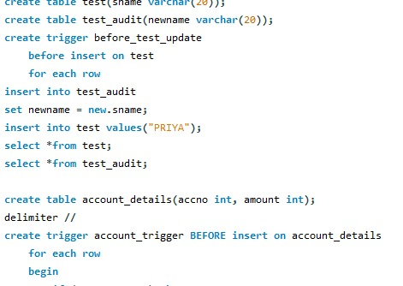

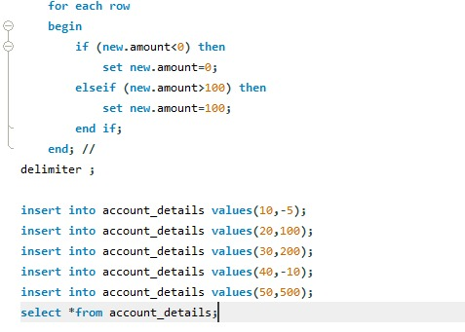

**Output:**

C:\Users\hi\Downloads\WhatsApp Image 2021-07-10 at 8.07.42 PM.jpeg

